**Step 1: Setup Git Repository**

**Description:**  
Navigated to the existing GitDemo repository and verified that the master branch is tracking origin/main.

**Commands Used:**

cd /c/Users/Dell/GitDemo

git checkout main

git branch -a

git pull origin master  
git fetch --all  
git checkout main  
git pull origin main

**Step 2: Create a New Branch**

**Description:**  
Created a new branch named Git-T03-HOL-002 and switched to it.

**Commands Used:**

git checkout -b Git-T03-HOL_002

**Screenshot(s):**  
555.PNG

**Step 3: Add Files in the Branch**

**Description:**  
Created a new file labfile.txt, added some content, staged it, and committed it.

**Commands Used:**

git add .

git commit -m "Git-T03-HOL_002 lab changes"

git push -u origin Git-T03-HOL_002

git checkout main

**Screenshot(s):**  
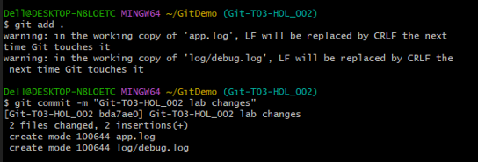

**Step 4: Push Branch to Remote**

**Description:**  
Pushed the newly created branch Git-T03-HOL-002 to the remote repository and set it to track the remote branch.

**Commands Used:**

git pull origin main  
git merge Git-T03-HOL_002  
git add .  
git commit  
git push origin main

**Screenshot(s):**  
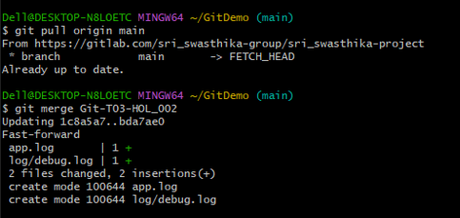

**Step 5: Verify on Remote**

**Description:**  
Checked the repository on GitLab and confirmed that the branch Git-T03-HOL-002 exists and contains labfile.txt.

**Commands Used:**

git branch –a

**Screenshot(s):**

